The SPC produces probabilistic Fire Weather Outlooks in conjunction with the traditional categorical Fire Weather Outlooks. These outlooks are issued for all Day 3 through 8 periods.

Categorical Fire Outlooks
The traditional Extended Fire Outlook is a categorical forecast that specifies the perceived level of threat via the descriptive wording: Critical (labeled by the period of the threat), Predictability Too Low, and Potential Too Low. However, this graphical outlook does not display the forecaster’s expectations of marginal, near-critical, or lower confidence fire weather events. While the accompanying discussion for the outlook usually describes the forecaster’s thoughts about the individual hazards, the accompanying categorical graphic does not.

Example Day 3-8 categorical Fire Outlook
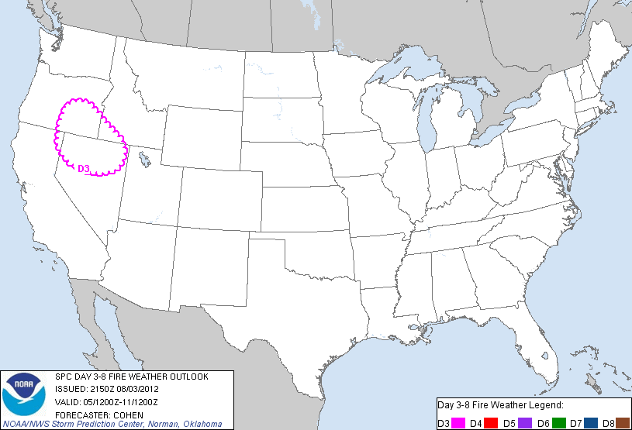
The outlook graphic defines the geographic threat areas. In the example above, a Critical Area for dry thunderstorms is delineated for northern Nevada, southeastern Oregon and southwestern Idaho. The graphic does not indicate the forecaster expectations of marginal, near-critical, or lower confidence fire weather events. This outlook will be discussed later in conjunction with the probabilistic forecasts for this event.

Probabilistic Fire Outlooks
Forecasting events such as a critical threat for wind, relative humidity and temperature or the occurrence of dry lightning is a very difficult process and one that contains a large amount of uncertainty. In the traditional categorical Extended Fire Outlooks, this uncertainty is conveyed via the Critical, Predictability Too Low, or Potential Too Low terminology. A more direct method of expressing the forecaster’s uncertainty is to use probabilities. Probabilities directly express a level of confidence that an event will or won’t occur. While probabilities may seem somewhat difficult to understand at first, once you have a grasp of how to interpret them, you will quickly gain an appreciation for how much more information they provide than Critical, Predictability Too Low, or Potential Too Low by themselves. (A great introduction to why probabilistic forecasting is so useful may be found in an online essay by Chuck Doswell and Harold Brooks.)

Definition of the probabilities
The probabilities used in the SPC Fire Outlooks are known as subjective probabilities. The forecasters make their best estimate of the probability of an event occurring. The probability values forecast are not created automatically by a computer or via statistics, but by the SPC fire outlook forecaster.
The probabilities that you see on the graphics represent the probability of a critical fire weather threat and/or lightning-based ignition occurring within 12 miles of a point. The probability of fire weather at a given point is quite small. Also, the Fire Outlook is not a small-scale, short-term forecast, but one that covers the entire contiguous United States for periods up to 24 hours. There is a large amount of uncertainty in forecasting fire weather on these scales. How many times have you experienced hot, dry and windy conditions when vegetation is dry, or even a wildfire in your neighborhood? For most people, the answer is never. Now think of how many times these conditions have occurred within 12 miles of your location. It’s probably safe to say you can think of a few wildfires that occurred nearby. How large of an area is a circle with a 12 mile radius?
Below you'll see the Oklahoma City metro area where the large blue circle represents such an area.
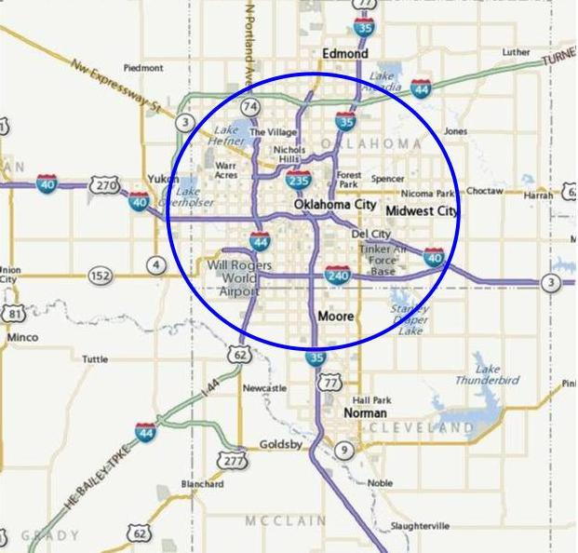
You should be able to imagine that the probability of having fire weather occur within such an area is much larger than the probability of having it occur specifically within any one neighborhood. Keep this in mind as we further discuss the probability values expressed in the outlooks.
So, how do you interpret the forecast values? As an example, a 70% solid line contour on the probabilistic forecast outlines an area where critical fire weather conditions during the forecast period is 70%. A critical risk area in this case is defined as critically low relative humidities (which vary by region), strong winds, and warm temperatures concurrent for at least 3 hours with dry fuels within 12 miles of a point. Larger values imply greater risk. For example, if the probability for critical conditions in your area is 70% on a given day and it was 40% the day before, there is a higher threat for your area on that day than the day before. Although 40% is not a very large probability for having critical fire weather conditions occur near you on a given day, it represents a 2 in 5 chance. To better understand this, let's put the probability values into perspective in terms of climatology.
The climatology of fire weather is very different than the climatology of precipitation. Compare the number of days that you experience rain at your home to the number of days that you have had warm, dry and windy conditions with dry fuels, or even a wildfire. Or how about a fire started by lightning? The number of times a given location experiences fire weather in a year is much less frequent than the amount of time it experiences rainfall. Because rainfall occurs so frequently (on average) the daily climatological values approach 20% on any given day in many locations east of the Rockies (i.e., a 1 in 5 chance, or it rains 1 day out of 5 on average). Suppose you hear a forecast calling for a 40% chance of rain. You can immediately say that the forecaster believes the chance of rain is twice as high as normal. This does not mean that rain will definitely occur but does mean that the forecaster believes that there is a higher than normal risk of precipitation occurring on that day. A climatological knowledge of the event being forecast is useful, even necessary for interpreting the probabilities being forecast. In the case for probability of precipitation forecasts, these values typically run from 0% (certainty that it will not rain) to 100% (certainty that it will).
Since critical fire weather occurs relatively infrequently, there is a large amount of uncertainty as to precisely where it will occur. Additional complications arise when you factor in whether an ignition will occur or not. Accurate yes/no forecasts of whether or not you will experience a large wildfire in your neighborhood in the next 24 hours are simply not possible many hours ahead of time. Further, the role of the Extended Fire Outlook is not to pinpoint the specific location for fire ignition, although the SPC does forecast where a heightened threat of lightning-based ignition will occur. The product is a national-scale forecast that highlights areas over the lower 48 states where meteorological conditions support large fire spread should an ignition occur.
The following table shows the range of probabilities used in the various probabilistic outlooks:
Day 3-8
Any fire weather | 10%, 40%, 70%

How should you interpret these values? The smallest values represent areas where the most uncertainty exists and correspondingly where the smallest expected coverage of critical fire weather conditions or lightning-based ignitions exists. The higher the probabilities, the greater the perceived threat and the greater the expected coverage of that hazard being forecast. The highest probabilities are generally reserved for more probable critical fire weather events.

Description of the probabilistic outlooks

Day 3-8
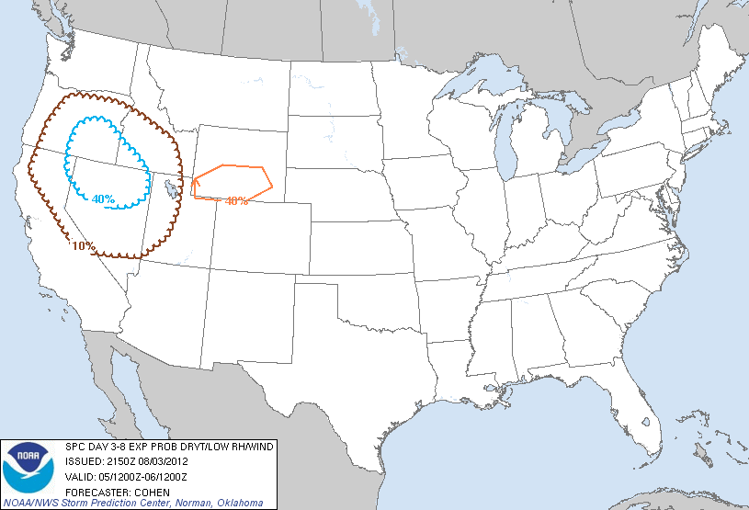
Above is the categorical outlook issued at 2150 UTC on August 3, 2012 as well as the corresponding D3 probabilistic forecast valid for the same time period. The conventional categorical outlook depicts a large Critical area for dry thunderstorms (shown in a pink scalloped line) for portions of northern Nevada, southeastern Oregon and southwest Idaho. An emergency manager, fire personnel and support, or member of the general public may use this graphic to determine the relative level of threat for their area. However, forecaster expectations of exact locations of large fires are not provided.
The second figure displays the probabilities of dry thunderstorms (brown 10% and blue 40% scalloped lines), as well as the probability of strong winds, low relative humidities and warm temperatures concurrent for at least 3 hours with dry fuels within 12 hours of a point (shown by the orange 40% line). By examining the probabilistic outlook, users may identify areas where a potential fire weather threat exists, but the criteria for a critical issuance is not met.

Benefits of the probabilistic Extended Fire Weather Outlooks
We believe the new Probabilistic Extended Fire Weather Outlooks do a better job of expressing uncertainty, as well as detail, compared to the traditional Extended Fire Weather Outlooks. These outlooks directly express forecaster uncertainty through the use of probabilities. Further, in the Day 3-8 period, forecaster expectations of critical fire weather conditions and/or lightning-based ignitions are explicitly conveyed through individual forecasts. By producing forecasts of each hazard individually, users who are sensitive to one particular threat (e.g., repositioning fire fighting resources) can make more informed decisions.
Even without a complete understanding of what the probabilities mean, you can directly assess from the graphics:
- Geographic areas where the various fire weather hazards are expected. These areas may or may not overlap with one another.
- The perceived levels of threat for the fire weather hazards. The higher the probabilities are, the increased threat of that hazard occurring. Refer to the discussion above concerning the probabilities used in the outlooks and especially the range of probabilities used.

