SPC Fire Weather Forecast Criteria
Elevated for temperature, wind, and relative humidity:
- Sustained winds 15 mph or greater (10 mph Florida)
- Minimum relative humidity within 5% of regional thresholds (Fig. 1)
- Temperatures above 45-55° F, depending on the season
- Dry fuels (as defined below)
- Duration of 3 hours or more – or critical conditions expected for a duration of less than 3 hours

Critical for temperature, wind, and relative humidity:
- Sustained winds 20 mph or greater (15 mph Florida)
- Minimum relative humidity at or below regional thresholds (Fig. 1)
- Temperatures above 50-60° F, depending on the season
- Dry fuels (as defined below)
- Duration of 3 hours or more

Extremely Critical:
- Sustained winds 30 mph or greater (25 mph Florida)
- Relative humidity at or below 1/3 lower than regional thresholds (Fig. 1)
- Temperatures at or above 60-70° F, depending on the season
- Very dry fuels (as defined below)
- Duration of 3 hours or more
- Extremely critical may also be considered for borderline weather conditions where exceptional drought exists
- Extremely critical delineations are made when wind, relative humidity and temperatures significantly deviate from climatological normals.

Isolated Dry Thunderstorms:
- 10-39% coverage of cloud-to-ground lightning strikes with rainfall AOB 0.10”
- Temperatures above 45-55° F, depending on the season
- Dry fuels (as defined below)

Scattered (Critical) Dry Thunderstorms:
- 40% or higher coverage of cloud-to-ground lightning strikes with rainfall AOB 0.10”
- Temperatures above 50-60° F, depending on the season
- RH at or below regional thresholds
- Dry fuels (as defined below)

Further detail:

The SPC is responsible for forecasting meteorological conditions which, when combined with the antecedent fuel conditions, favor rapid growth and spread of a fire should an ignition occur. Although the ignition source of a fire is often due to non-meteorological factors, the SPC does forecast dry thunderstorms, which are considered the only meteorological ignition source.

The SPC issues five categorical risk areas to highlight fire weather threats in the day 1 and 2 fire weather outlooks: elevated, critical, or extremely critical for temperature, wind and relative humidity (RH), as well as a isolated or scattered (critical) for dry thunderstorms. A critical or extremely critical fire weather area is issued for a given area if, in the judgment of the forecaster, critical conditions mentioned above will persist in an area for a duration of three hours or more. The outlook type depends on the severity of both the forecast weather and the antecedent conditions relative to the given geographic region. Most outlook delineations are either elevated or critical fire weather areas, as extremely critical areas are reserved for significant deviations from climatological normals. Elevated fire weather areas now replace “see text” areas within outlooks and are designed to highlight areas where either sufficient uncertainty precludes a critical area designation or the expected weather conditions will be just below criteria for a critical area.

Although the SPC does not explicitly forecast fuel information, the dryness of the fuels is closely tied to both short- and long-term meteorological conditions. In the short-term, hot and dry atmospheric conditions can rapidly modulate the dryness of fuels that are available to burn. In the long-term, patterns that favor below normal rainfall and above normal temperatures can result in drought and a larger degree of curing relative to climatology. Since the SPC forecasts conditions that are favorable for fire spread, these long- and short-term effects on fuels are taken into primary consideration prior to issuing a highlighted area.

Fuel information is utilized from a variety of external sources. This includes drought and climate information from the CPC, live (herbaceous and woody) and dead fuel moisture levels from the Wildland Fire Assessment System, the National Fire Danger Rating System (NFDRS), departures from normal rainfall, and recent rainfall. Most significantly, fuel dryness level forecasts GACCs are heavily relied upon for a baseline of where fuels are appropriately dry to warrant a highlighted area. These fuel dryness levels were created after research by the Pacific Northwest GACC found a correlation between the Energy Release Component (ERC) for fuel model G and 100 hr fuel moistures, which are available from the NFDRS, to the occurrence of large fires given an ignition. Since the ERC is a composite of fuel moistures from all size classes of fuel with a heavier weight towards larger 100-hour fuels, the associated fuel dryness levels created by the GACCs are fairly representative of both daily fluctuations in fuel moistures with the 100-hour fuels, and longer-term changes with the ERC (Marsha 2008). The application of the Pacific Northwest GACC PSA model varies slightly nationwide, depending on the predominant fuel class size used in the model. Regardless, values of dry and very dry (when available) are considered necessary prior to SPC issuing a highlighted area.

Meteorologically, the primary factors for fire spread are the magnitude of the sustained wind speeds, the duration and level of relative humidity (RH), and the temperature. Generally, for national guidance purposes, sustained wind speeds of 20 mph or greater, RHs lower than a threshold value (varying from 15-35%) and temperatures above 50-60° F, depending on the season, will necessitate the issuance of a critical delineation. The criteria for RH varies regionally, depending on the predominant fuel type and climatology (Fig. 1). For instance, the grasslands of the southern High Plains would require a minimum RH of 15% or less, while the heavily forested areas of New England and portions of the Pacific Northwest coast would have a higher threshold at 30% or less. In terms of the Fosberg Fire Weather Index (FWI) (Fosberg 1978), this would generally equate to values above 40-50. For an extremely critical delineation, minimum criteria generally requires sustained wind speeds of 30 mph or greater, and temperature and RH values that are significantly deviant from climatological normals for the time of year and location. This can be somewhat subjective, but due to internal coordination and external collaboration efforts, SPC fire forecasters have found that the issuances of these higher-end forecasts are generally consistent internally between fire forecasters and externally with our fire weather partners.

Critical areas for dry thunderstorms are issued when an outbreak of dry thunderstorms is expected to occur, heightening the risk of fire ignition due to cloud-to-ground lightning, assuming a dry fuel bed. Generally, numerous to widespread coverage of thunderstorms producing one-tenth of an inch or less of precipitation can be expected. Similar to a critical area issuance, a 3-hour or greater period of critically-low RHs and the presence of a dry fuel bed are necessary for a dry thunderstorm area issuance. This particular outlook type is issued infrequently, similar to high risk issuances in the SPC convective outlooks.

The SPC also issues a daily day 3-8 fire weather outlook. There are three primary types of operational graphics issued: a critical area for temperature, wind and RH, “predictability too low”, and “potential too low”. A critical area for dry thunderstorms may also be issued, but this is rare given the inherent challenges in forecasting lightning coverage with minimal rainfall. “Predictability too low” is reserved for situations where a critical fire weather area is possible during the forecast period, but model uncertainty provides low confidence in the evolution of a potential event. Meanwhile, “potential too low” is used when the impending weather pattern is unfavorable for critical fire weather conditions to develop, regardless of model spread. In 2011, an experimental product was introduced that highlights potentially marginal fire weather areas, or areas that may be upgraded to a critical area at a later time when confidence increases in a given scenario. “Probability too low” is used on the probabilistic graphic when either the probability of a given critical fire weather scenario is low, or model predictability precludes the issuance of a marginal or critical area delineation.
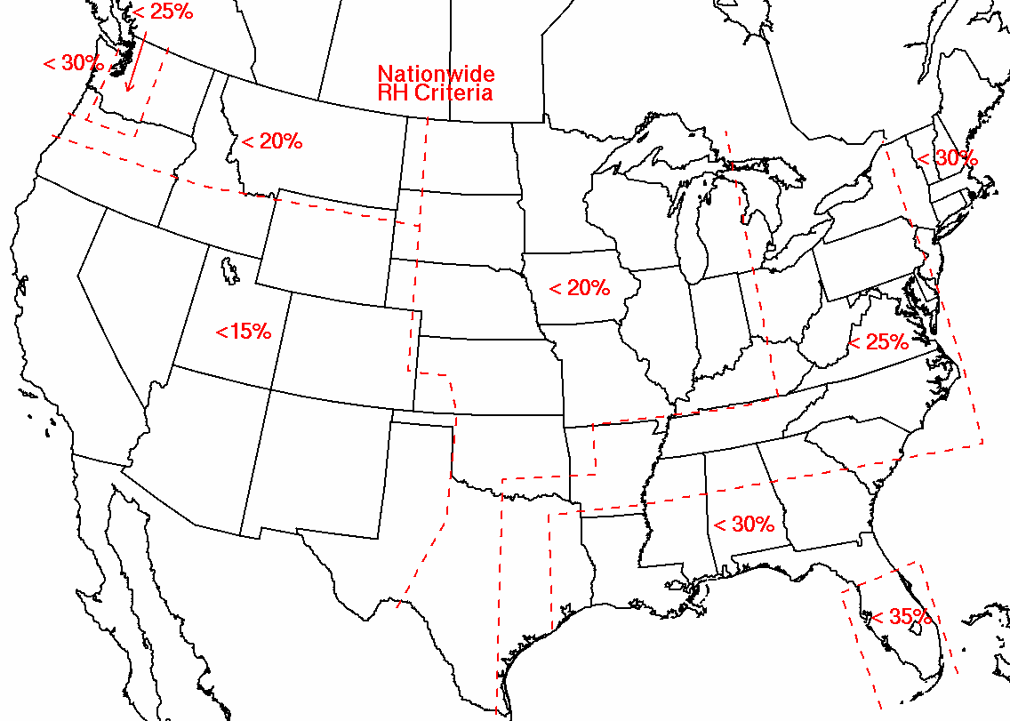
Fig. 1: Regional relative humidity thresholds for SPC critical fire weather issuance.

References
Fosberg, M.A. 1978: Weather in Wildland Fire Management: The Fire Weather Index. Proc. Conference on Sierra Nevada Meteorology, Amer. Meteor. Soc., 1-4.

Marsha, Terry, cited 2008: Assessing Daily Fire Potential. [Available online at http://www.nwccweb.us/content/products/fwx/publications/Assessing_Daily_Fire_Severity1.pdf].

